**NOTE PHYSICS 4 - THEORY**

**(Midterm)**

1. **Vibration. Resonance**
2. **In simple harmonic oscillation:**

+ The restoring force:

+ Displacement of simple harmonic motion:

$$x=Acos\left(ωt+ φ\right)$$

with: $ω= \sqrt{\frac{k}{m} }$

(k: string constant (N/m); m: mass of the object(kg))

+ The period: ;

+ Frequency: $f= \frac{1}{T}= \frac{ω}{2π}$

1. **The physical pendulum:**

+ Angular displacement: $θ=θ_{0}\cos\left(ωt+ φ\right)$

with: $ω= \sqrt{\frac{mgd}{I}}$ (I: inertia moment; d: the distance from the rotating point)

+ The period:

+ In the simple pendulum: $T=2π\sqrt{\frac{L}{g}}$

1. **Force Oscillation and Resonance:**

+ In damped oscillation, the displacement is:

$$x=Ae^{-\left(\frac{b}{2m}\right)t}\cos\left(ωt+ φ\right)$$

with: $ω= \sqrt{\frac{k}{m}-\frac{b^{2}}{4m^{2} }}$ (b: damping coefficient (kg/s))

+ In force oscillation:

$$x=Acos\left(ωt+ φ\right)$$

with: $A= \frac{F/m}{\sqrt{{\left(ω^{2}-ω_{0}^{2}\right)}^{2}+{\left(\frac{bω}{m}\right)}^{2} }}$; $ω_{0}= \sqrt{\frac{k}{m}}$

if $ω= ω_{0} resonance$

1. **Mechanical Wave**
2. **The wave function:**

$$y=Asin\left(\frac{2π}{T}t- \frac{2π}{λ}x\right)=Asin\left(ωt-Kx\right)$$

with: $λ=vT$ ($λ:wavelength ;v:the speed of wave$)

and: $K= \frac{2π}{λ}$ (K: the wave number)

1. **The speed of waves on strings:**

$$v= \sqrt{\frac{T}{µ}}$$

with: T: tension of the string (N)

µ: mass per unit length (kg/m) $\left(µ= \frac{m}{L}\right)$

1. **Superposition and Interference:**

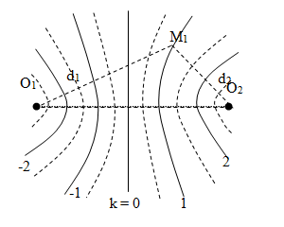

The general function of interference;

$$x=2Acos\left(\frac{ϕ}{2}\right)\sin\left(ωt-Kx_{1}+ \frac{ϕ}{2}\right)$$

For the phase difference:

$$ϕ=k2π constructive interference (2A)$$

$$ϕ=\left(2k+1\right)π destructive interfence \left(0\right)$$

For the path difference:

**In case two waves are in the same phase**

$$δ=d_{1}-d_{2}=kλ constructive interence$$

$$δ=d_{1}-d_{2}=\left(k+ \frac{1}{2}\right)λ destructive interference$$

**In case two waves are out of phase**

$$δ=d_{1}-d_{2}= \left(k+ \frac{1}{2}\right)λ constructive interence$$

$$δ=d_{1}-d_{2}=kλ destructive interference$$

1. **Standing wave**

The position of the nodes: $x= \frac{nλ}{2}$ (n = 1,2,3,…)

The position of the antinodes: $x=(n+\frac{1}{2})λ$ (n= 1,2,3,..)

**In a string fixed at both ends:**

* The wavelength: $λ_{n}= \frac{2L}{n}$ (n = 1,2,3,…)
* The frequency: $f_{n}= \frac{v}{λ_{n}}=\frac{nv}{2L} = \frac{n}{2L}\sqrt{\frac{T}{µ}}$ (n = 1,2,3,…)

⇨ The fundamental frequency: $f_{1}= \frac{1}{2L}\sqrt{\frac{T}{µ}}$ and $f_{n}=nf_{1}$

**In a pipe opened at both ends:**

* The wavelength: $λ_{n}= \frac{2L}{n}$ (n = 1,2,3,…)
* The frequency: $f_{n}= \frac{v}{λ_{n}}=\frac{nv}{2L} = \frac{n}{2L}\sqrt{\frac{T}{µ}}$ (n = 1,2,3,…)

⇨ The fundamental frequency: $f_{1}= \frac{1}{2L}\sqrt{\frac{T}{µ}}$ and $f_{n}=nf_{1}$

**In a pipe closed at one end:**

* The wavelength: $λ_{n}= \frac{4L}{n}$ (n = 1,3,5,…)
* The frequency: $f_{n}= \frac{v}{λ_{n}}=\frac{nv}{4L} = \frac{n}{4L}\sqrt{\frac{T}{µ}}$ (n = 1,3,5,…)

⇨ The fundamental frequency: $f_{1}= \frac{1}{4L}\sqrt{\frac{T}{µ}}$ and $f_{n}=nf_{1}$

(n is odd number)

1. **Sound wave:**

+ Normal human can hear from 20Hz to 20000Hz

+ The intensity of sound wave: The rate at which the energy flows through a unit area

$$I= \frac{P}{A}= \frac{P}{4πr^{2}}$$

with: P is the power

+ The intensity of sound level:

I0: threshold of hearing ($I_{0}={10}^{-12} W/m^{2})$

1. **Doppler effect:**

$$f^{'}= \frac{v+ v_{0}}{v- v_{s}} f$$

$v:$ the speed of sound

$v_{0}$: the speed of the observer

$v_{s}$: the speed of the source

⇨ The motion is toward ⇨ Higher frequency

⇨ The motion is away ⇨ Lower frequency

**3) Wave Optics:**

**a) The nature of light:** The photon energy:

$$ε=hf= \frac{hc}{λ}$$

$$h={6.63 x 10}^{-34} J.s$$

**b) Interference of light wave:**



The path difference:

$$δ=d_{1}-d_{2} ≈dsinθ ≈dtanθ= d\frac{y}{L}$$

* Bright fringe: $δ= d\frac{y}{L}=kλ y_{bright}=k\frac{L}{d}λ=ki$

$$(i= \frac{L}{d}λ)$$

Angular position: $δ= dsinθ=kλ$

* Dark fringe: $δ= d\frac{y}{L}=\left(k+\frac{1}{2}\right)λ y_{dark}=\left(k+\frac{1}{2}\right)i$

Angular position: $δ= dsinθ=(k+\frac{1}{2}) λ$

The intensity: $I=I_{0}\cos^{2}{(\frac{πdsinθ}{λ}})=I_{0}\cos^{2}{(\frac{πdy}{Lλ}})$

**c) Interference in a thin film**

+ Change of phase due to reflection

* ⇨ 1800 phase change
* ⇨ no phase change

+ The wavelength of light in a medium

+ The interference in a thin film

* **Constructive interference: $2nt=(m+\frac{1}{2})λ$**
  + (m = 1,2,3,..)
* **Destructive interference: $2nt=mλ$** (m = 1,2,3,…)

(t: the thickness of the film; n: refraction index of the film)

**d) Light diffraction:**

+ The general condition for destructive interference

$sinθ=m\frac{λ}{a}$ (m = 1,2,3,…)

(a: the width of the split)

+ Position of dark fringe

+ The intensity at each point on the screen

$$I= I_{max}{\left[\frac{\sin\left(\frac{πasinθ}{λ}\right)}{\frac{πasinθ}{λ}}\right]}^{2}$$

* If ⇨ all the light concentrate at the geometrical focus
* If a < ⇨ The central maximum spread over 1800 ⇨ Cannot see the fringe

**e) Diffraction grating:** consider a large number of splits, all with the same width a and spaced equal distances d between centers

The condition for maximum intensity:

$dsinθ=mλ$ (m =1,2,3,…)

(d: grating spacing)

For grating spacing d: d = $\frac{Length}{Number of splits}$

**f) Diffraction of X-rays by crystal**

The Bragg equation (for the path difference)

$$δ=d_{1}-d_{2} ≈2dsinθ$$

($θ$: the incident angle; d: the distance between adjacent planes)

**g) Polarization:**

The intensity of the light transmitted through the analyzed:

$$I= I_{max}\cos^{2}{ϕ}$$

($ϕ:the angle between two polarizer axis)$

For the unpolarized light passing through a polarizer:

I = $\frac{I_{max}}{2}$

**4) Geometric Optics**

**a) Refraction and Reflection**

**+ Index of refraction:**

$$n= \frac{c}{v}$$

( $v:$ the speed of light in a medium)

**+ The law of reflection**: The angle of reflection is equal to the angle of the incident light

$$θ_{i}=θ_{r}$$

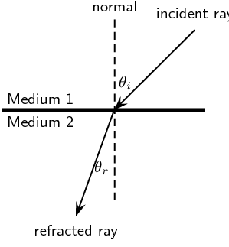**+ Snell’s Law of Refraction:**

$$n_{i}sinθ_{i}= n_{r}sinθ_{r}$$

**+ The critical angle for total internal reflection:**

$sinθ_{crit}=\frac{n_{r}}{n_{i}}$ (if $n_{i}> n_{r})$

**b) Thin lenses:**

**+ The focal length f (the lens maker’s equation):**

$$\frac{1}{f}=(n-1)(\frac{1}{R_{1}}- \frac{1}{R_{2}})$$

* If ⇨ converging lens
* If ⇨ diverging lens

**+ Thin-lens equation:**

$$\frac{1}{f}= \frac{1}{p}+ \frac{1}{q}$$

* If: ⇨ Real object; ⇨ Virtual object
* If: ⇨ Real image; ⇨ Virtual image

**+ Magnification:**

$$M= \frac{h^{'}}{h}=-\frac{q}{p}$$

* If ⇨ The image is the same direction as the object (erect image)
* If ⇨ The image is opposite direction to the object (inverted image)

**+ For the two lenses system:**

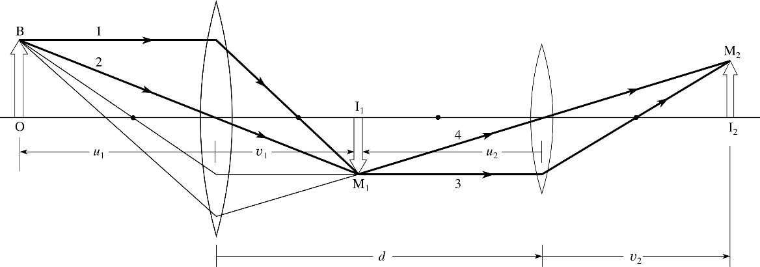

* Thin-lens equation for lens 1:
$$\frac{1}{f_{1}}= \frac{1}{p_{1}}+ \frac{1}{q_{1}}$$

* The distance between lens 1 and lens 2:
$$d=q_{1}+p_{2}$$

* Thin-lens equation for lens 2:
$$\frac{1}{f_{2}}= \frac{1}{p_{2}}+ \frac{1}{q_{2}}$$

* Total magnification:

$$M=M_{1}.M_{2}= \frac{q_{1}}{p_{1}}.\frac{q_{2}}{p_{2}}$$

**c) Prism (optional)**

$$sini=nsinr$$

$$sini^{'}=nsinr^{'}$$

$$A=r+ r^{'}$$

$$D=i+ i^{'}-A$$

For minimum deflection:

$$i=i^{'}$$

$$r=r^{'}= \frac{A}{2}$$

$$D_{m}=2i-A$$

**d) Mirrors (optional)**

$$\frac{1}{f}= \frac{1}{p}+ \frac{1}{q}$$

$$f= \frac{R}{2}$$